Assignment 3 Report

**How to run the code**: run the files, there is no menu, but there are parts where the user has to interact with the terminal and give values.

**Q1: Queue Manipulation** with push(), pop(), front(), size() and empty() functions.

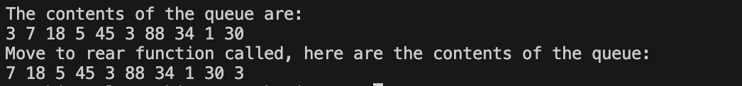

**Q2: Linear Search** with Recursion

Outputs the values in the vector, then asks for a value to search for (this is being done recursively) and displays a statement with the index of where that value occurs last in the vector, if at all.

**Q3: Insertion Sort** – Sorts a linked list of integers.

